HARLAWHILL DAY CARE CENTRE

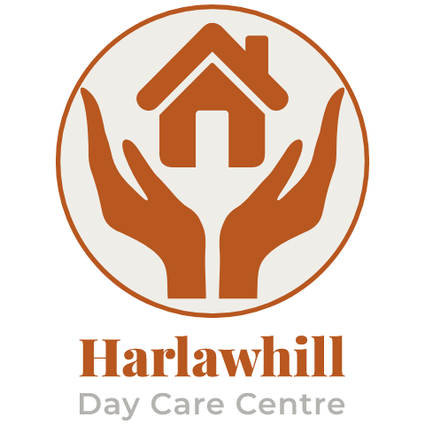
MEMBER’S PARTICIPATION STRATEGY

Contents

1. About the Strategy
2. Who Are ‘Members’
3. Why We Need to Involve Members
4. About Participation
5. Our Participation Principles
6. How Much Participation
7. Where We Are Now
8. Our Strategy Aims
9. What We Will Do to Meet the Aims
10. Who Will Make It Happen
11. Setting and Reviewing Targets

This document can be made available in large print on request. Additionally a member of our staff team can read aloud to anyone if they require it.

1. About The Strategy
This strategy is for you – the people who use Harlawhill Day Care Centre and the staff and volunteers who support you.
Harlawhill has been operating since June 1992. We are dedicated to providing support and care to older people and their carers within the Prestonpans area.
We aim to provide a quality day care service with a high level of support and stimulation, which enables our members to function to the limit of their abilities and to remain independent and stay in their own home for as long as possible.
We have been a registered charity since opening in 1992 and are now run by a Volunteer Board of Trustees and have 8 members of staff and 3 volunteers.
Harlawhill is committed to “hearing the voice” of its members. This strategy aims to build on our existing work of promoting good working relationships with our service users and to help us to develop a more consistent approach to user participation

2. Who Are “Members”
The term Member includes the following people
- People who use our services
- People who may use our services in the future
3. Why We Need To Involve Members
There are many good reasons to involve members. These include:
- To give people a say in the services we offer and the way we provide them.
- To find ways to tailor our services to meet our members’ individual needs.
- To make sure we continue to provide quality services that are friendly, fair and useful.
- To make sure that our services support a person’s dignity and independence.
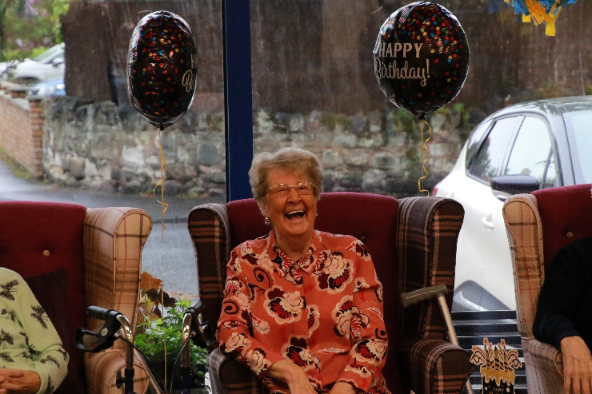

4. About Participation
User participation is about talking and listening to members and involving them as partners in the decisions that affect their lives. Examples can include:
- Involving members in decisions about their own health and social care needs and how these are to be met.
- Consulting members in the planning of activities.
- Supporting members to take part in the selection of staff.
We believe that service users have the right to have their say, to enjoy choice and control, and to share in the decision making about their services.
At the same time, we recognise that there are limits to this right and we must be open and honest at all times.
We have legal duties and responsibilities that we must carry out. Occasionally, we may need to make decisions that may go against the wishes of members. If this happens, we will clearly explain our actions as well as people’s right to appeal or make a complaint.
Having set out some of these limits to user participation, we are committed to making sure that members are able to contribute to all areas at the centre and all that we do and the way in which we do it.
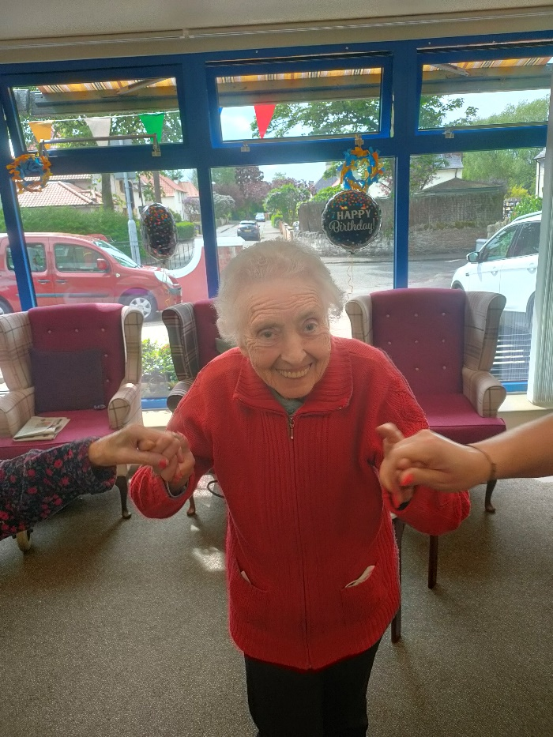

5. Our Participation Principles
In involving members we will:
- Treat people with dignity and respect at all times.
- Work and make decisions with people.
- Be fair and just with people.
- Make sure that people are encouraged and supported to speak their minds and have a say about our services.
- Make sure that we are always user-friendly and that all our participation activities are accessible to members.
- Be clear with people on what they are being asked to be involved with, how their views will be used, and when they will be informed of the results.
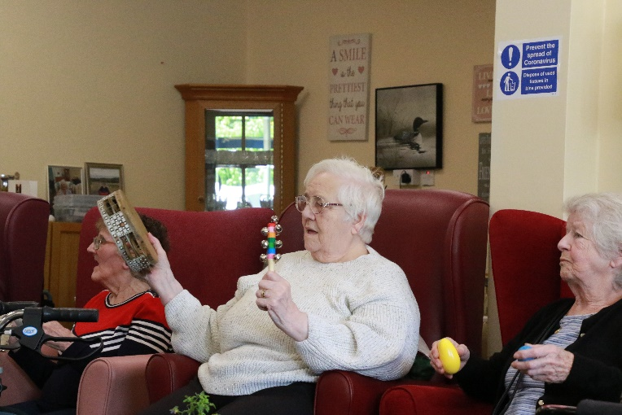

6 How Much Participation?
Participation can range from members being involved in decisions about their own services to taking part in the management, planning and development of services within the centre.
For some members, receiving information about the services can be enough. Other members will look to be more actively involved, wanting to give their views and expecting to take part in the decision-making process.

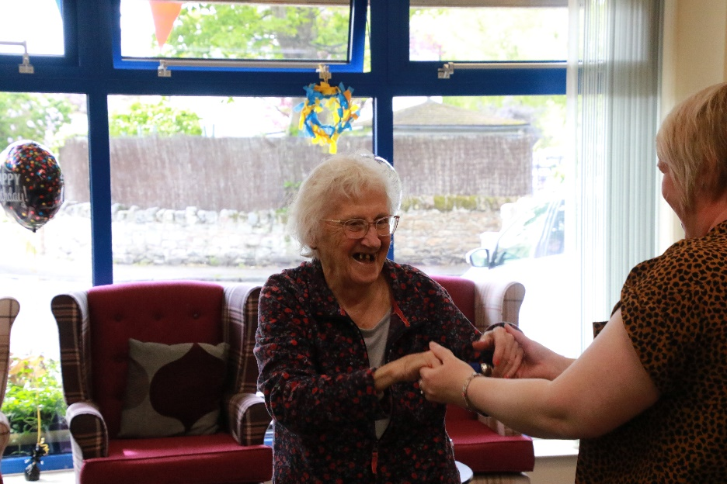

7. Where We Are Now
There are a number of areas in which we already include user participation within the way we work. Examples include:
- We listen to members’ voices and strive to act on this in the best way we can.

- We discuss lunch menus with members prior to a purchase order being made and prepare accordingly.

- Our comments and suggestion box: members can choose to submit their views and opinions, with their own name or can do so anonymously.

- Our annual members’ survey is also an opportunity for members to give their views on the service provided to them.
In the future we aim to have: -
- More members involvement in the recruitment and selection of staff.

8. Our Strategy Aims
The strategy has five main aims:
- To develop User Participation in our service.

- To develop User Training and Support so that participation is meaningful and not just a ‘token effort’.

- To develop Staff and Volunteer Training and Support so that all staff and Volunteers in the service are able to make participation happen.

- To give Feedback on Progress made in putting this strategy into practice.

- To develop Standards and Targets so that our progress can be measured and reviewed.
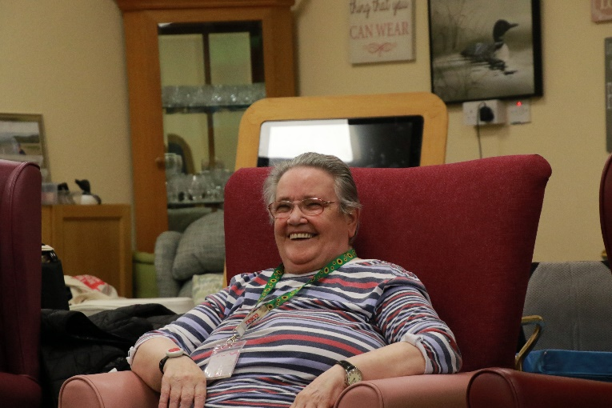

9. What We Will Do To Meet The Aims
User Participation
We will:
- Involve members in checking how well we currently practice user participation.
- Develop plans to fill unmet needs and gaps.
- Support members to have the opportunity to be involved in staff recruitment, including the development of job descriptions / person specifications, interview questions, and taking part in selection panels.
- Support members to be involved in the running of services, including taking part in making decisions about how the services are organised and delivered, and how they measure up.
- Create opportunities for members to be involved in the development of services.
- Create opportunities for members to be involved in checking and contributing to our published information e.g., our newsletter, website and social media channels.

User Training and Support
We will:
- Develop training and support for members to build confidence and to ensure that participation is meaningful at all levels.

- Help members to have their say through advocacy support.

- Develop training on Quality Standards, Best Value and other important areas. From our Best Practice in Dementia, we will gain knowledge of how best to encourage participation from this group.

Management / Staff / Volunteer Training and Support
We will:
- Publicise the User Participation Strategy to make sure that all Management, Trustees, Staff and Volunteers are aware of what it says and understand their part in making it happen.

Feedback on Progress
We will:
- Develop suitable ways to feedback to members on how well we are doing in making the strategy happen and how long this will take us.

- Make sure that the results of participation and consultation are used to improve the service we provide them.

- Create opportunities and support for members to comment on the quality and usefulness of the services provided to them.
Standards and Targets
We will:
- Develop measurable and achievable targets for member participation in the delivery and development of services.

- Promote a systematic approach to member participation so that we always expand and extend the things we do well and improve on areas that need to be further developed.

10. Who Will Make It Happen
All those involved will have a role in making the strategy happen:
Members
Members are at the heart of the strategy and have a critical role in helping us to continue to develop user-friendly, accessible and fair services.
Staff, Volunteers and Trustees
Staff, volunteers and trustees play a key part in making the strategy happen. The will make sure that service users are informed of their rights and the required standards we work to.
Staff, volunteers and trustees will also support members to take part in their service and are able to contribute towards the planning and development of services within the centre and the community.
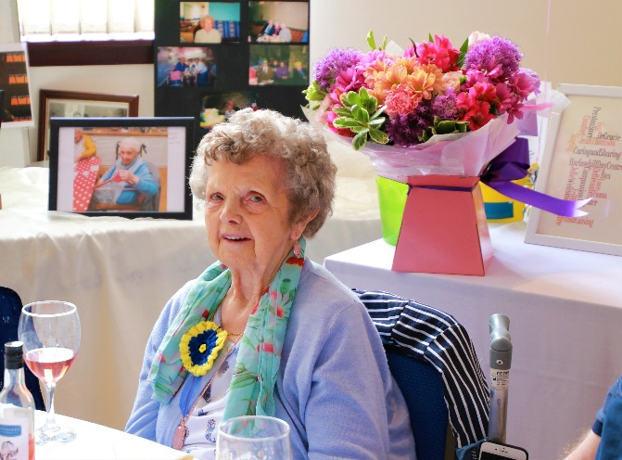

11. Setting and Reviewing Targets
This strategy will be regularly checked to ensure that it keeps up with the needs of the members, and also that it is fully up to date with our Policies and Procedures.
An Action Plan will be developed to make the Strategy happen. This Action Plan will be incorporated into our annual aims and objectives.
Progress made in making the Strategy happen will be reported withing our Annual Report.
All of our Policies and Procedures are publicly accessible to service users, their families and carers, staff members and volunteers.
We will ensure a high quality of professional services.
At the heart of our work is the relationships that we build with our members. As we get to know each other better, we are able to improve upon the support we provide. This is particularly important for members who have variable or deteriorating conditions as their needs can vary from day to day.
Our staff and volunteers spend a lot of time listening to our members and discover about their lives and interests. We use this information to make a one page profile and work on individual life stories for all.
As with all of our Policies and Procedures, we consider this is a work in progress and will review and update it periodically.
We aim to provide the best service possible with the resources that we have at our disposal and we believe that if we all participate together and follow our mission statement we can achieve our goals.

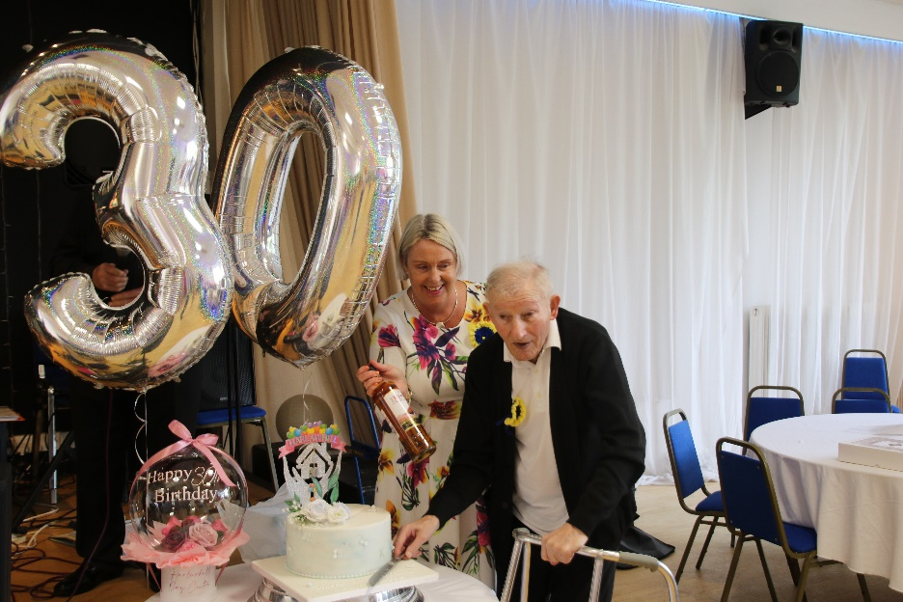

Mission Statement
Our aim is to provide the highest quality of day-care for older people within the Prestonpans area by:
- Operating in a safe and homely environment, we strive to enhance the quality of life of everyone who attends our day centre by treating each person as an individual, showing them compassion, fairness and respecting their privacy and dignity at all times.
- We strongly believe in the ethos of ‘see the person and not the illness and value every individual.’
- We encourage participation and involvement in every facet of our service.
- We encourage our clients’ independence to allow our members to experience the best of life.
- We work hard to boost the self confidence and general wellbeing of all our members.
- We aim to provide a forum where friendships are forged and happy memories created.
- We promote healthy living and wellbeing throughout or service.

Our staff and volunteers are all natural carers who are trained to the highest levels to allow us to achieve our mission.

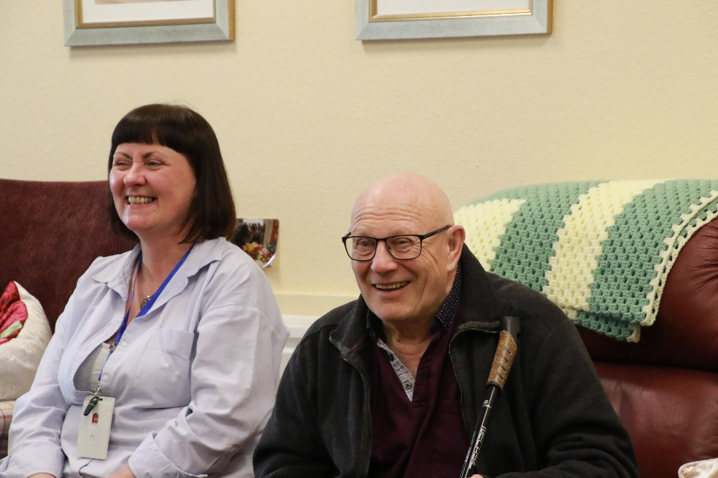

Written by Fiona Mitchell, Manager, with input from staff, volunteers, members and trustees.

