HARLAWHILL DAY CARE CENTRE

Proudly serving the elderly community of Prestonpans since 1992

WELCOME BOOKLET

MEET THE TEAM
Fiona Mitchell – Manager

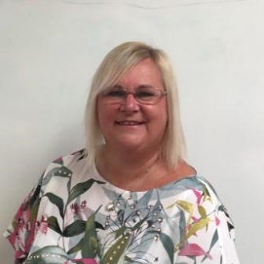
Gillian Hanratty – Senior Carer

Louise Lamb – Carer / Escort

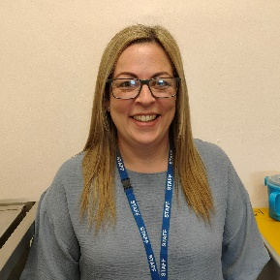
Emma Hillhouse – Carer / Escort

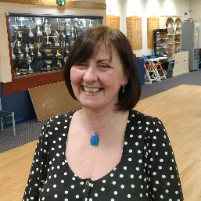

Jackie Stevenson – Carer / Escort

Yvonne McAuley – Morning Driver

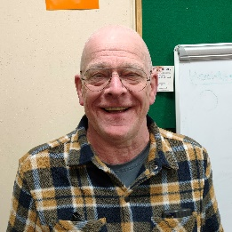

Dougie Paterson – Afternoon Driver

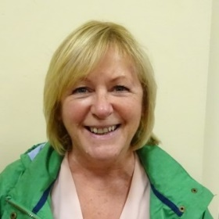

Avril Harris - Cleaner

OUR AIM

Our aim at Harlawhill Day Centre is to provide social contact and stimulation in homely surroundings for those who cannot get out of their house without assistance and who require care or supervision for at least part of the day.
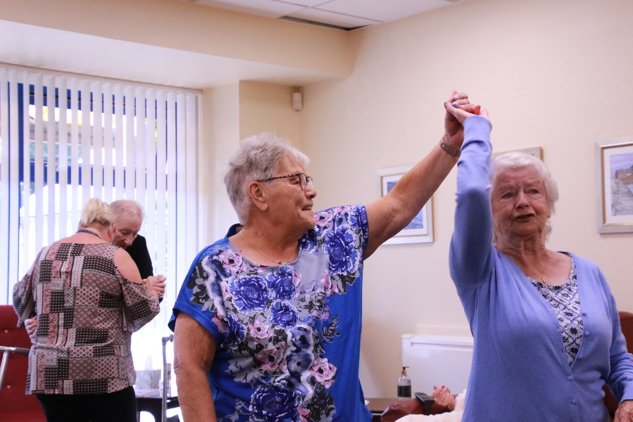
WHAT WE OFFER

We are open Monday to Friday offering up to 16 places per day and members are transported to the Centre in our specially adapted minibus.
We provide a light breakfast on arrival followed by a 2 course hot lunch and an afternoon cuppa, as well as refreshments throughout the day.
Activities at the Centre are led by the members and they are free to do as much or as little as they choose. If someone has a particular interest we will do our best to provide for it. Staff are always on hand to provide assistance as or when required.
The cost for this service is currently £12.50 per day paid 4 weeks in advance to ensure your allocated day is kept secure.
SEE FOR YOURSELF

If you want to have a look at what we do and how we do it then check out our website at
https://harlawhilldcc.co.uk
where you will find more details, photos, videos and news about the Centre.
You can also like our Facebook page at
https://www.facebook.com/HarlawhillDC
where you will see regular updates about what is happening here. This is also a great way for families and friends near and far to keep track of your time here and another way for them to get in touch with us.

CONTACT DETAILS AND USEFUL INFORMATION
Harlawhill Day Care Centre is a registered charity No SC020282 and is registered with the Care Inspectorate in Scotland.
We operate in partnership with East Lothian Health and Social Care Partnership and East Lothian Council to provide care for the elderly within Prestonpans.
We are fully insured and have policies and procedures in place to make sure we comply with all current legislation regarding Adult Social Care.
We are overseen by a Board of Trustees who meet regularly to discuss the running of the Centre with the Manager.
You can contact the Day Centre between 9 am to 4 pm Monday to Friday on 01875 814 989 or e-mail us at any time at hhdcc2007@yahoo.com

